Feb 15th

Revenue 484

Winnigs- 14+ 12.5+16.66=43

Total= 484+43= 527

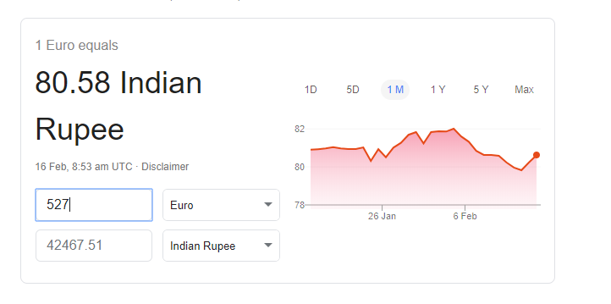

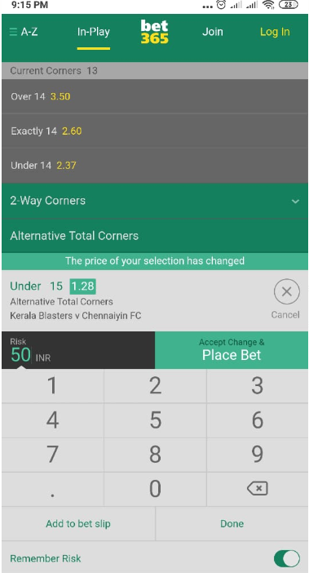

Won 14 euros



Won 12.50

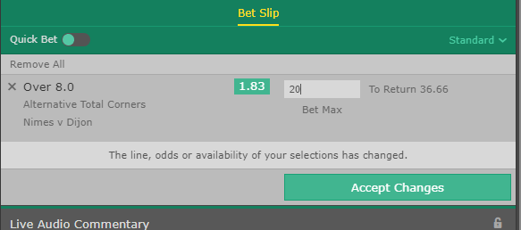

Won 16.66